EMPLOYEE ATTENDANCE MANAGEMENT SYSTEM

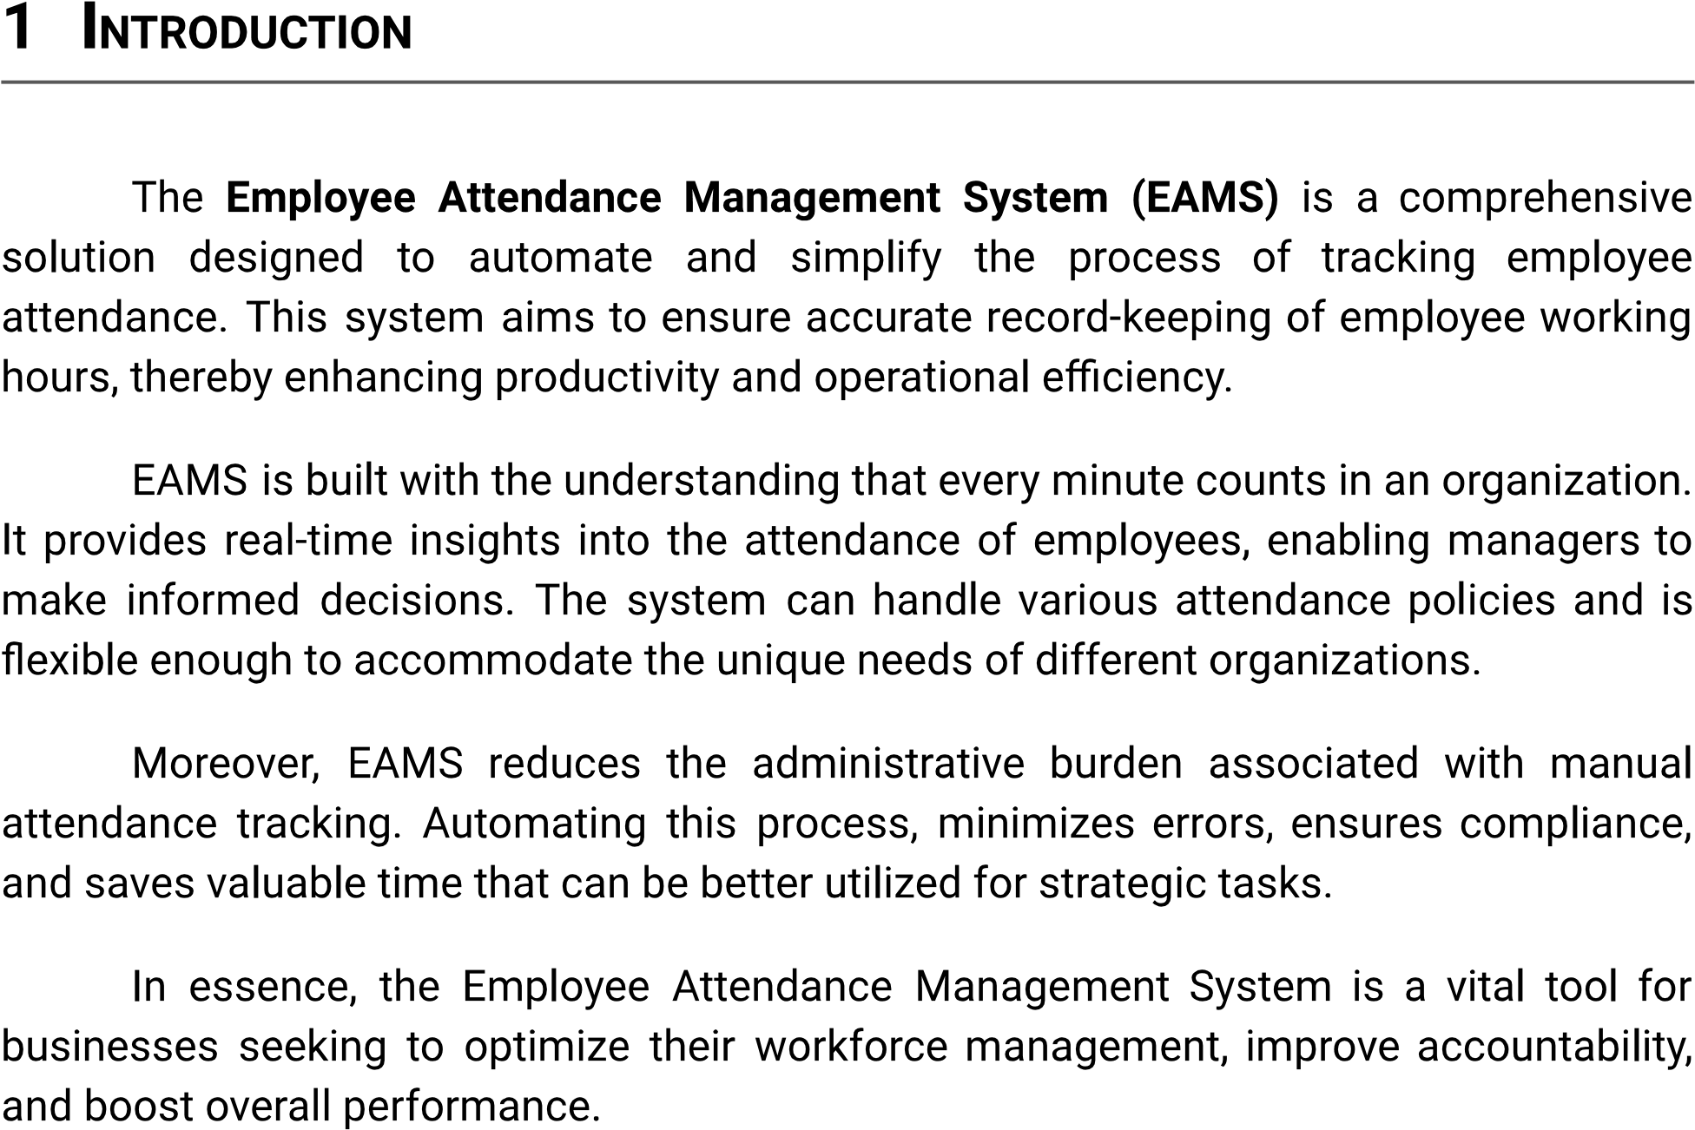

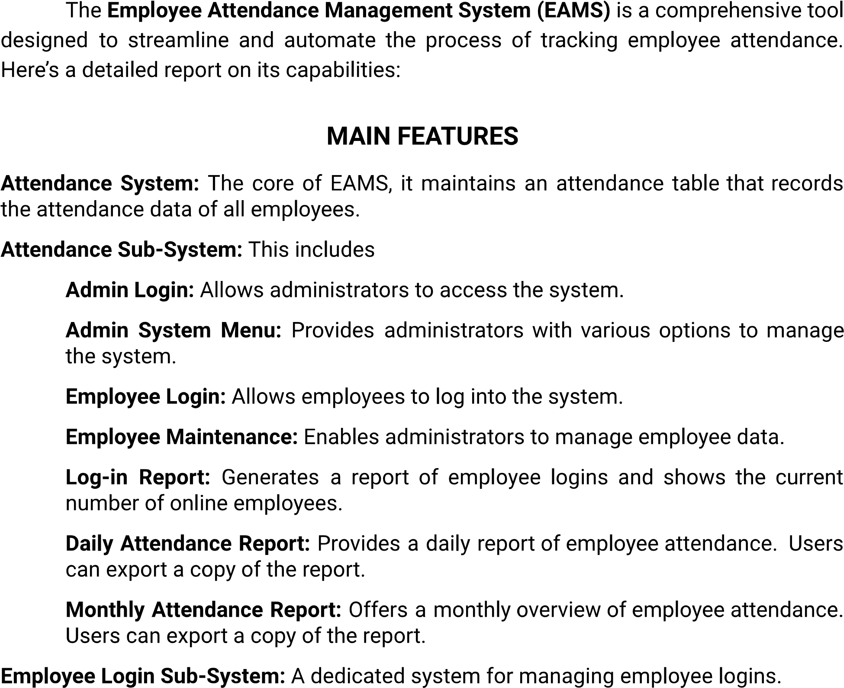

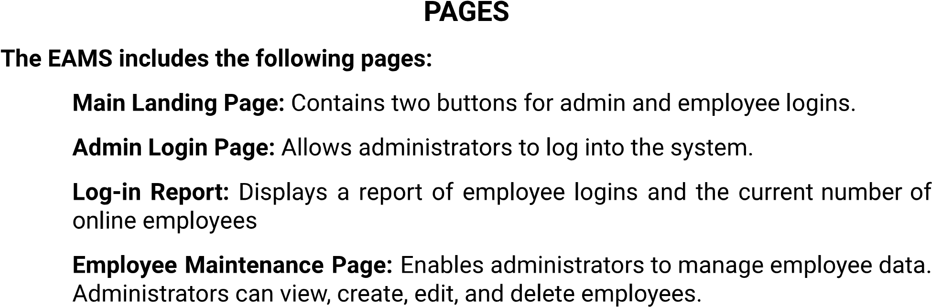

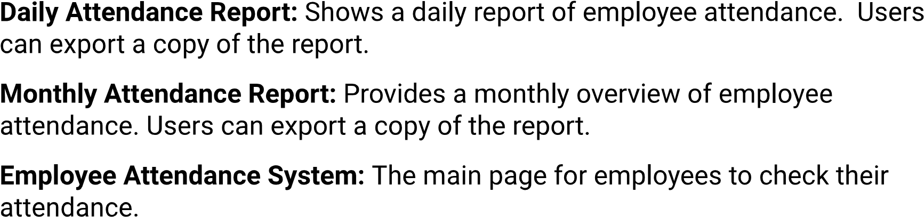

|  |  |
| --- | --- |
|  |  |
|  |  |
|  |  |
|  |  |
|  |  |
|  |  |
|  |  |

|  |  |
| --- | --- |
|  |  |
|  |  |
|  |  |
|  |  |

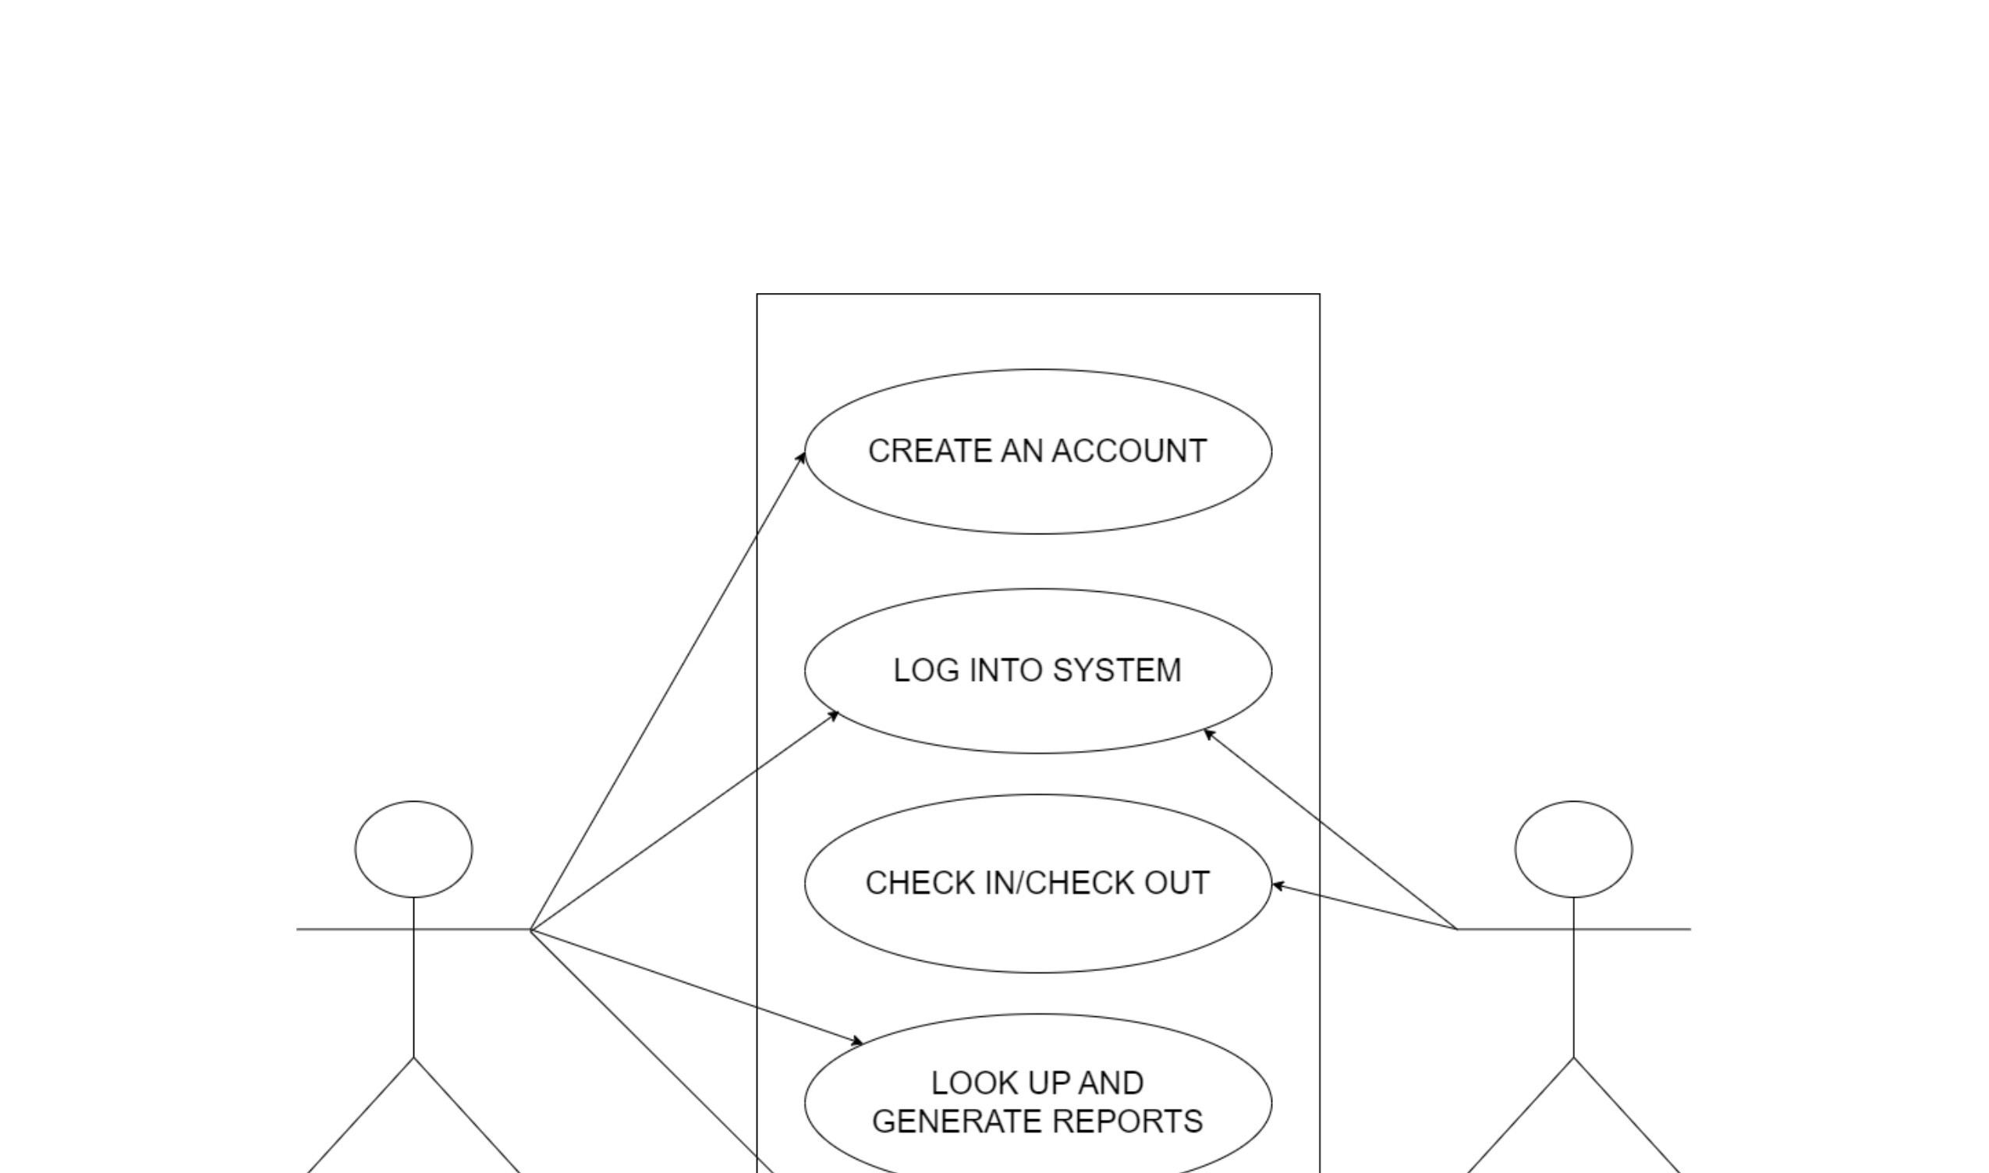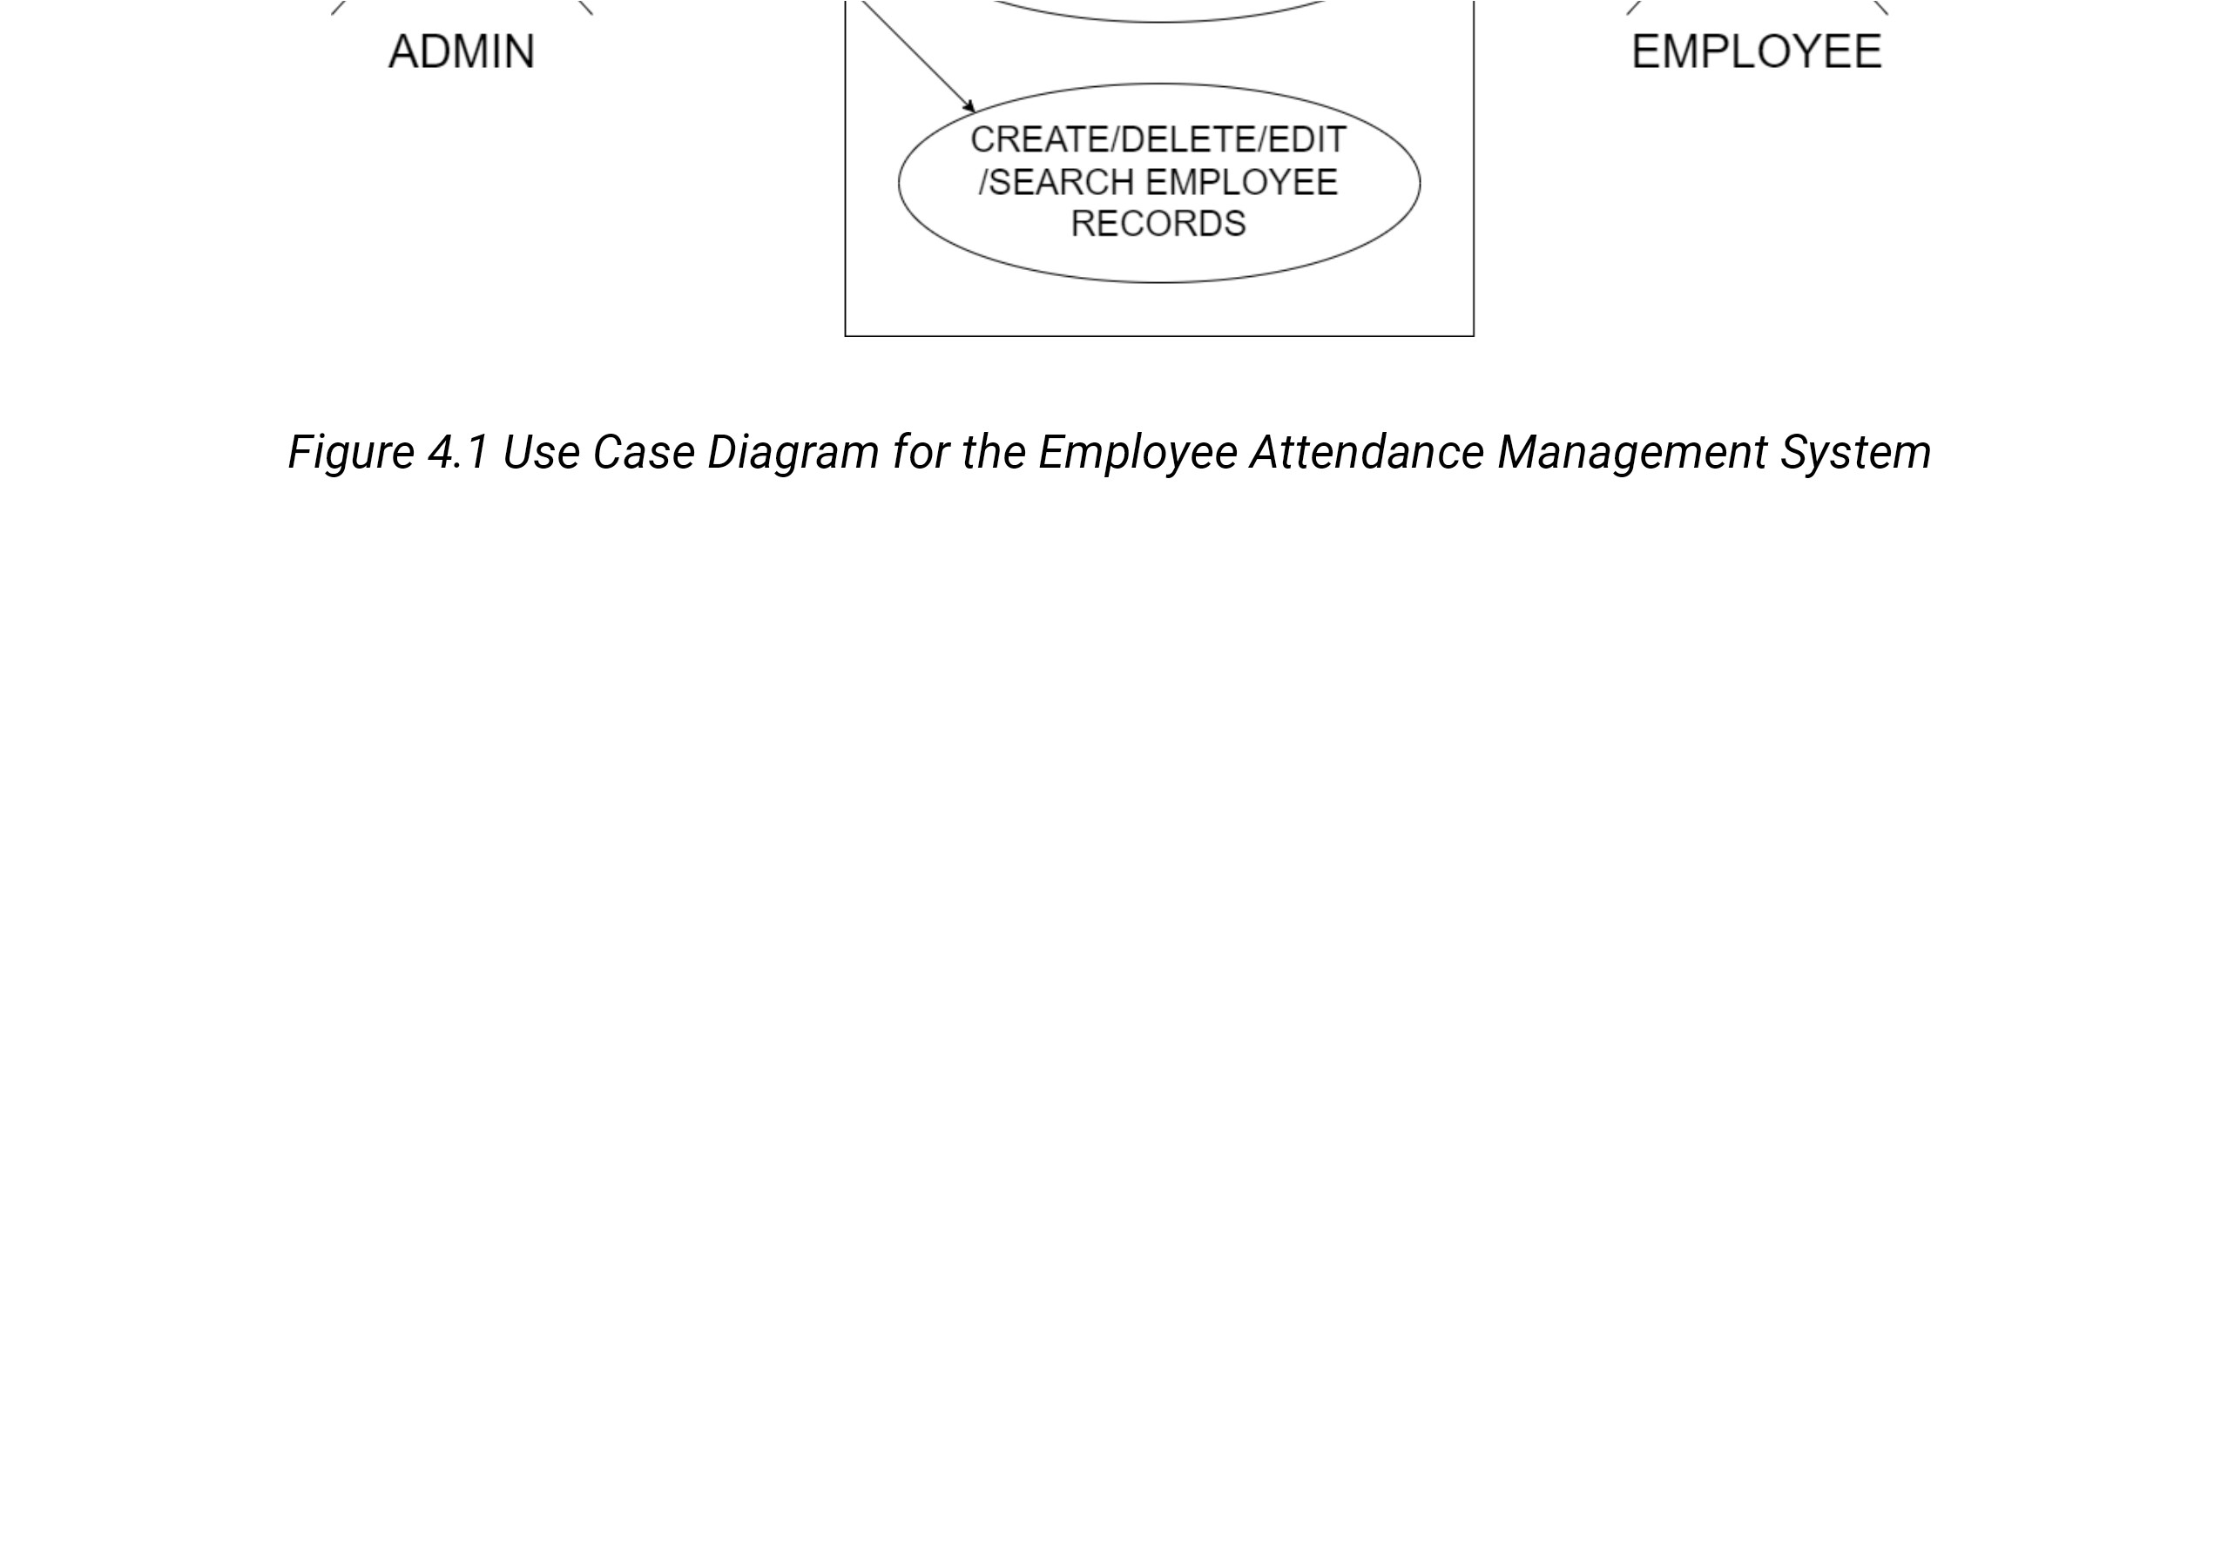

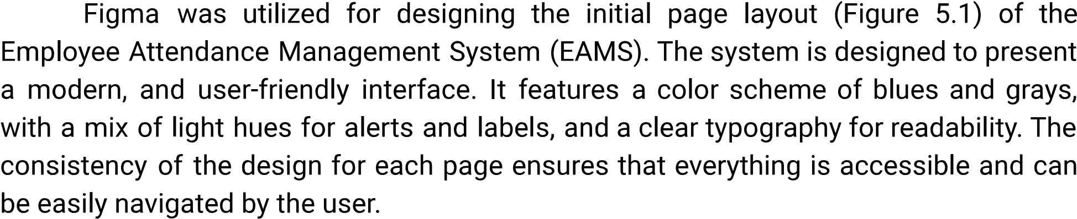

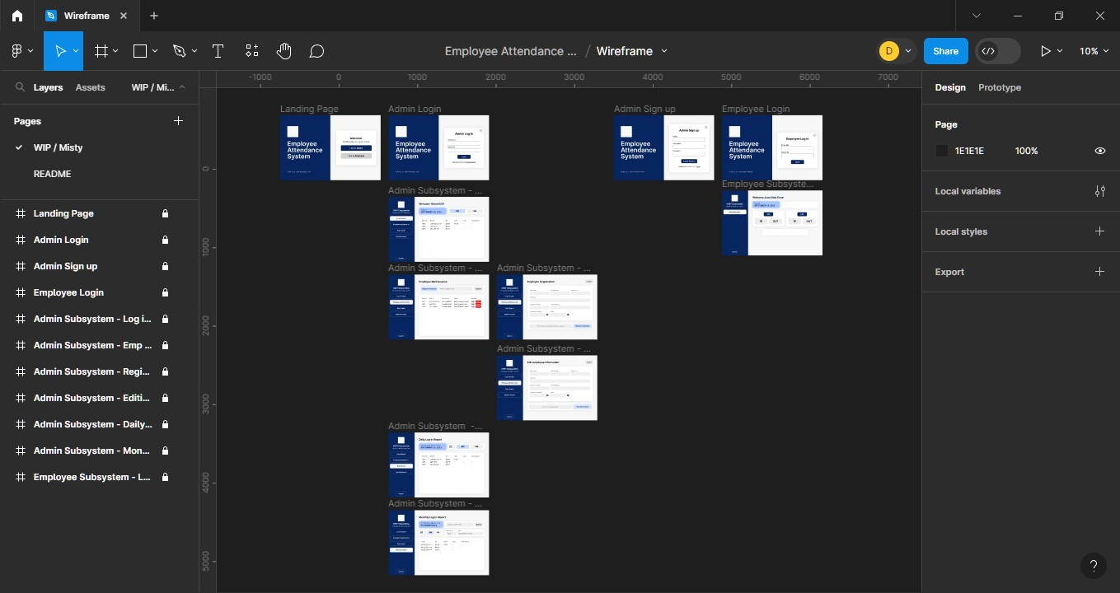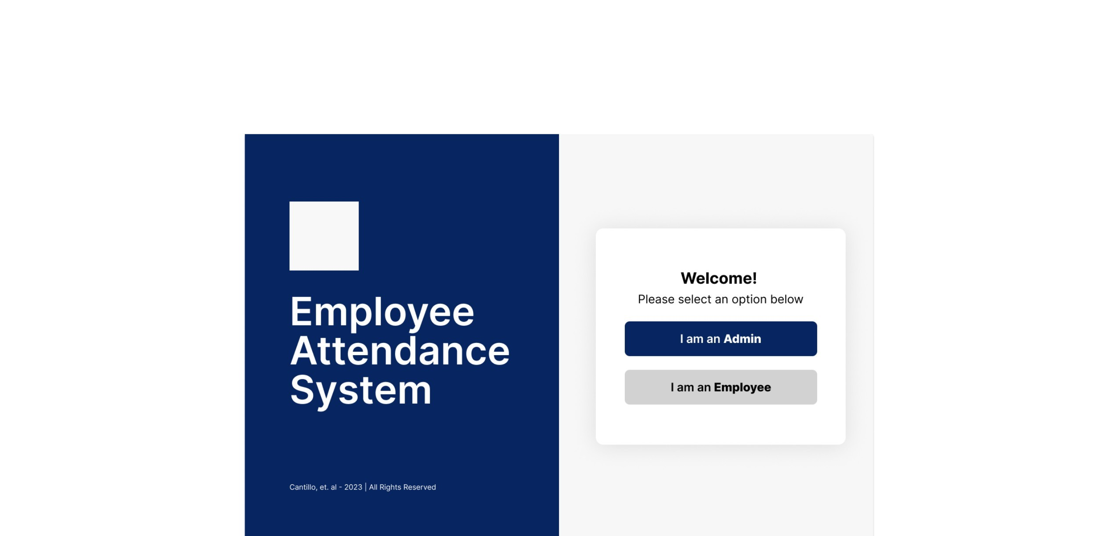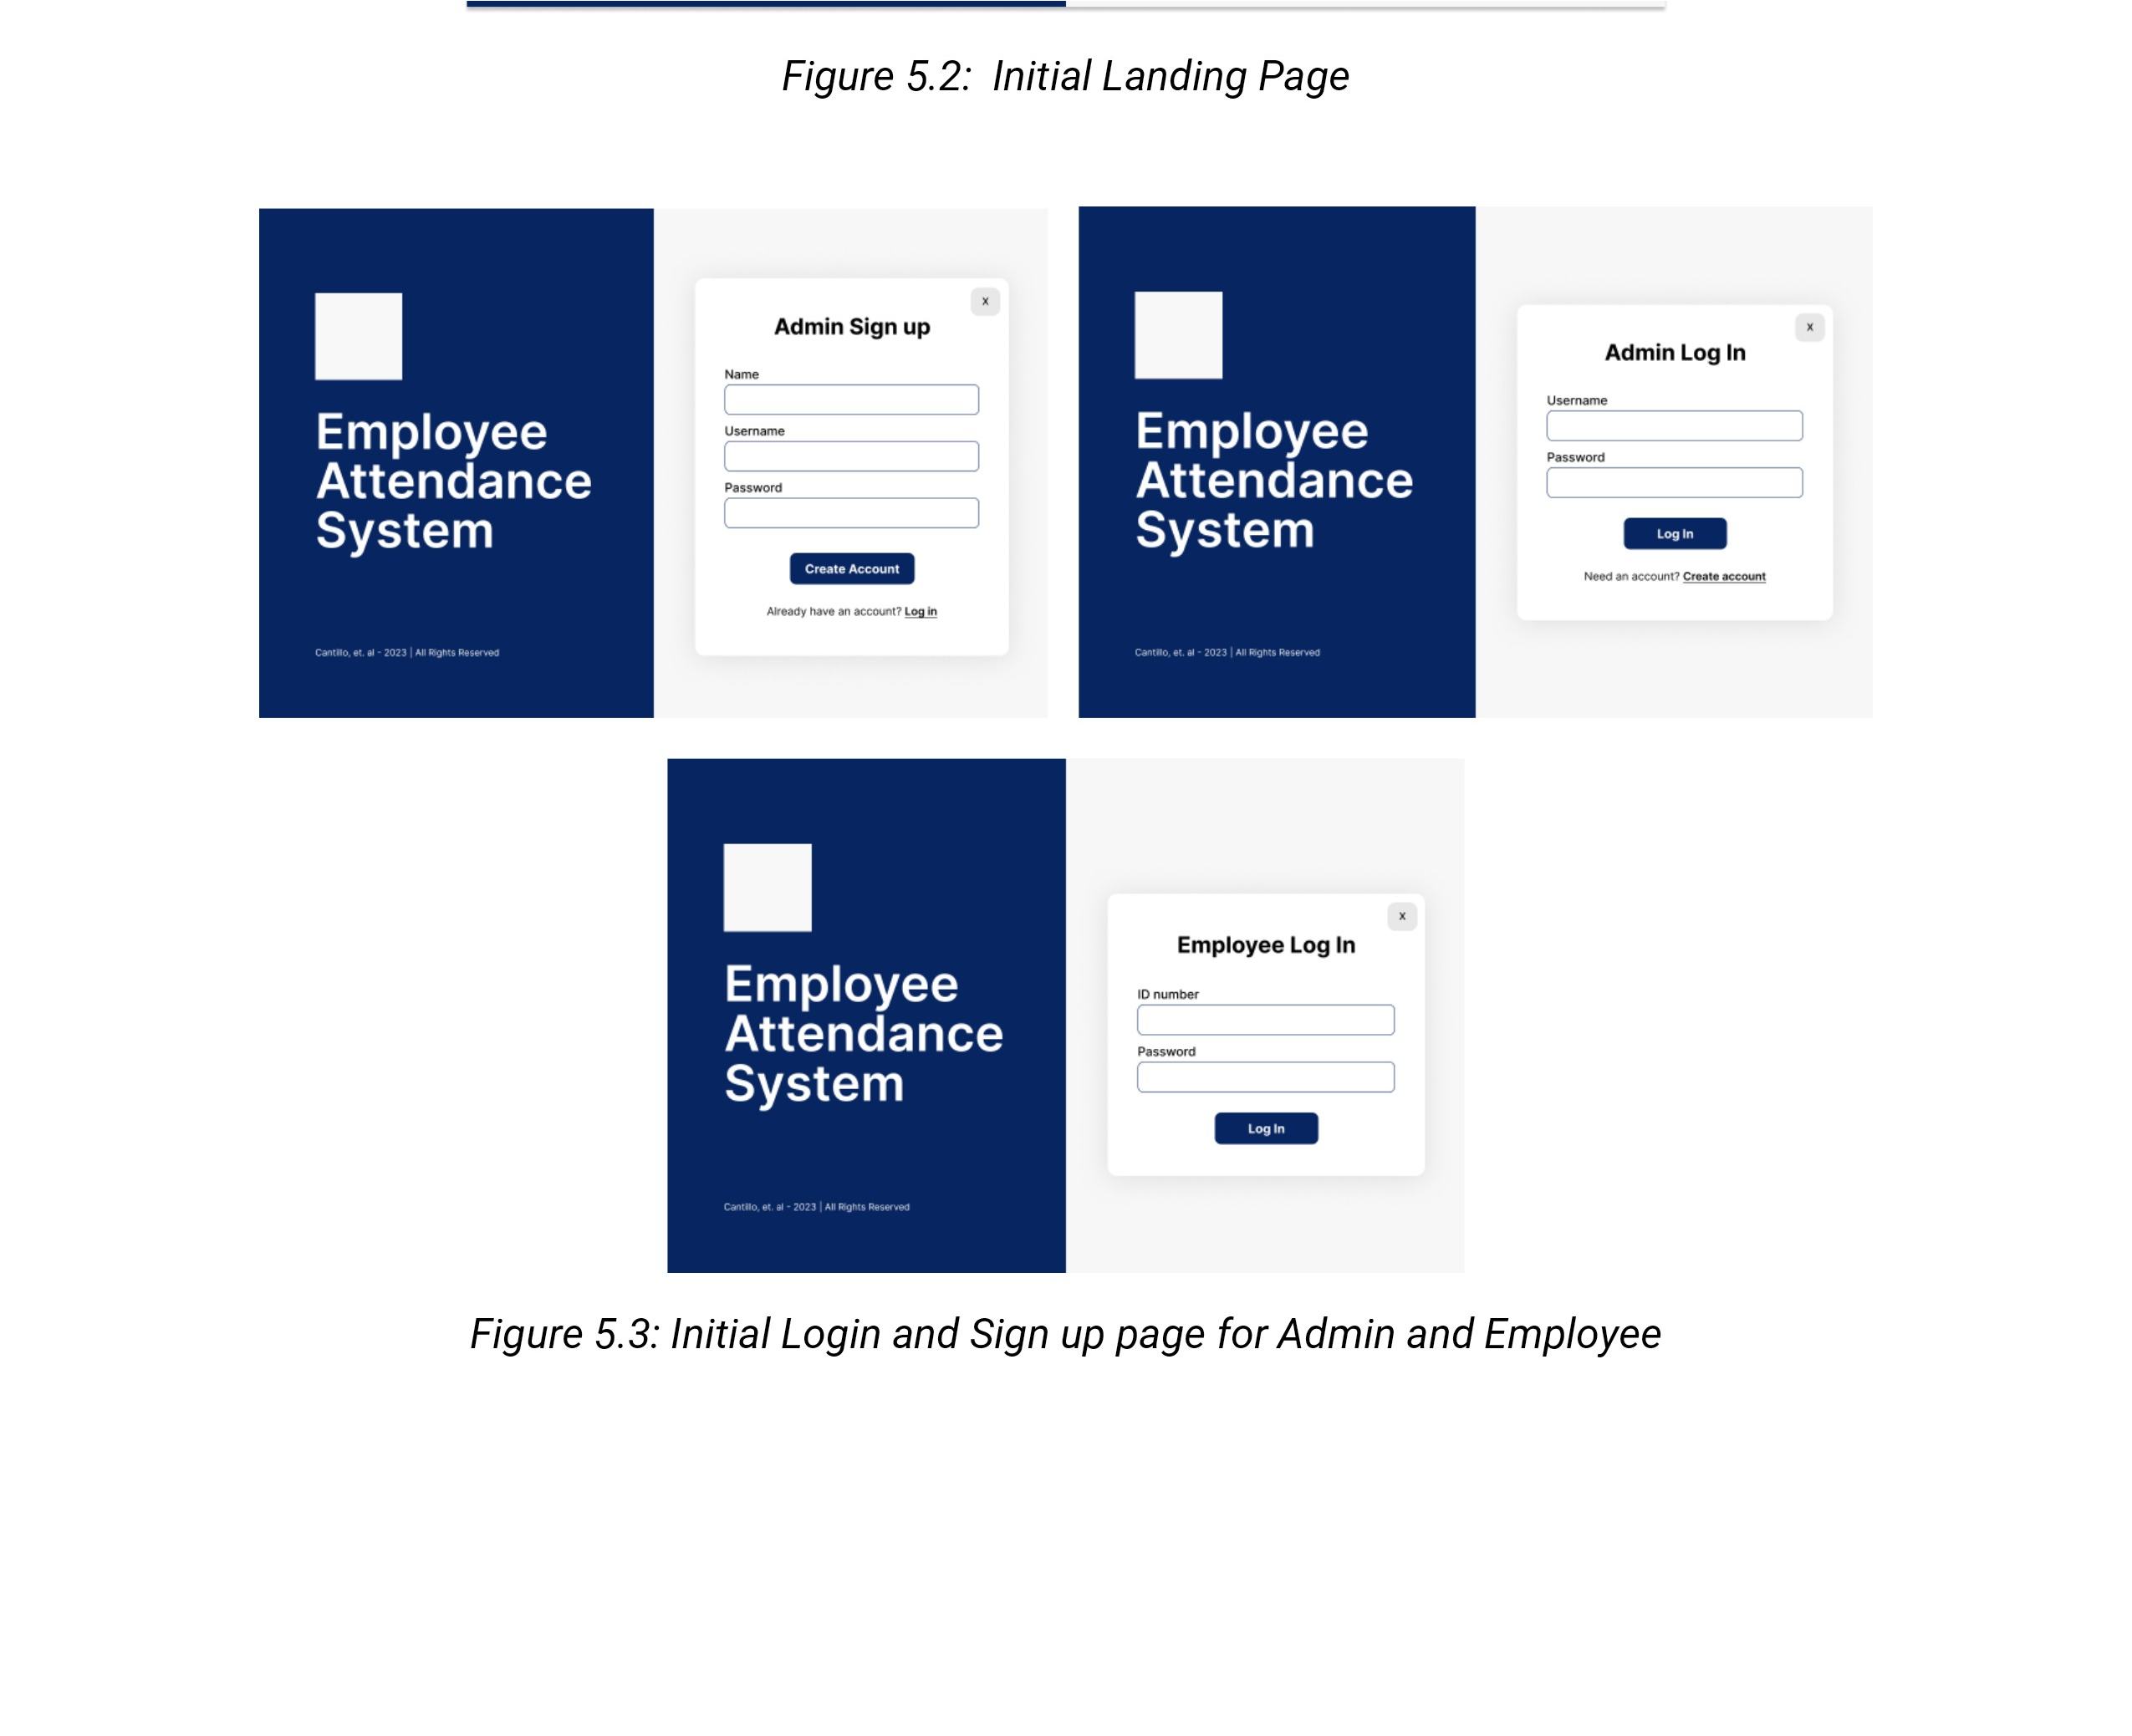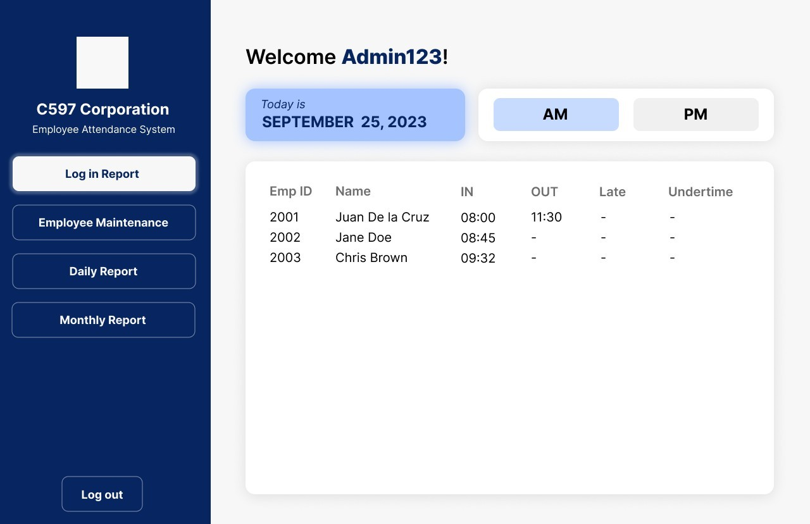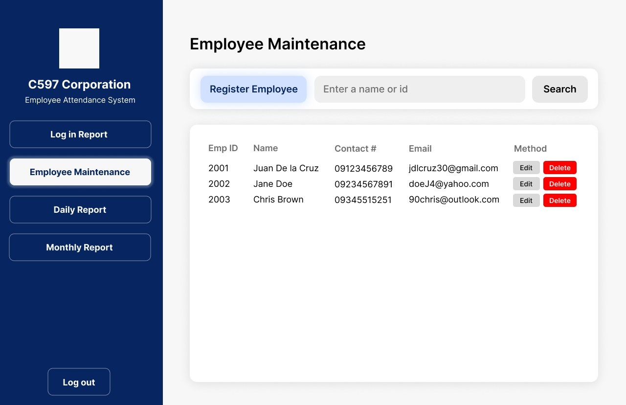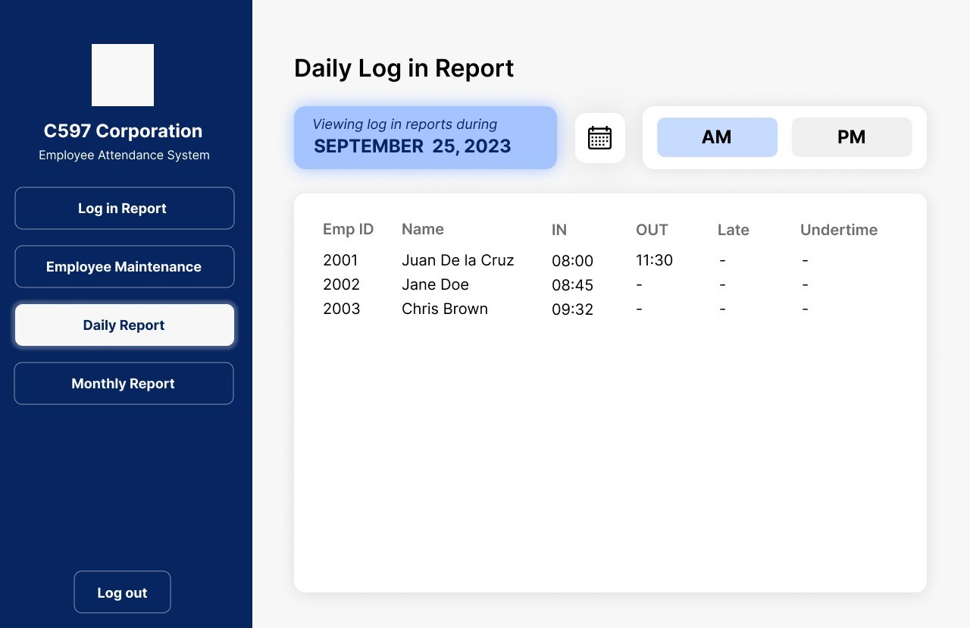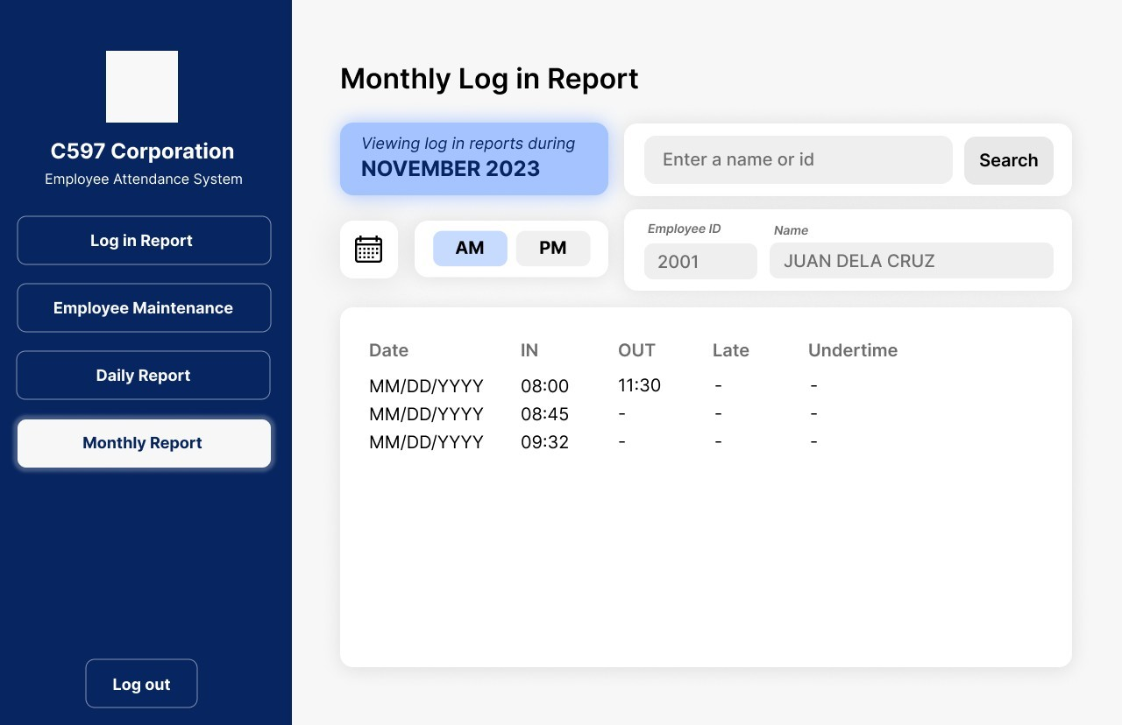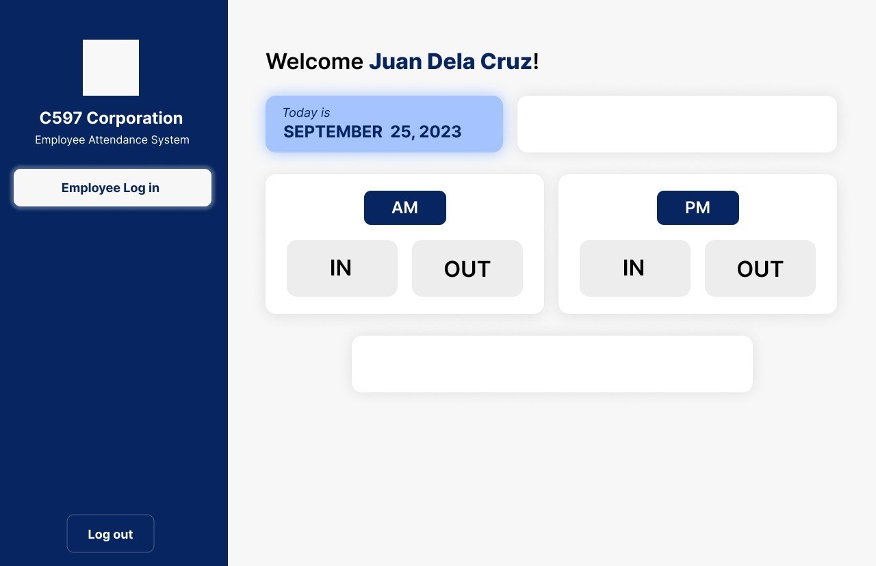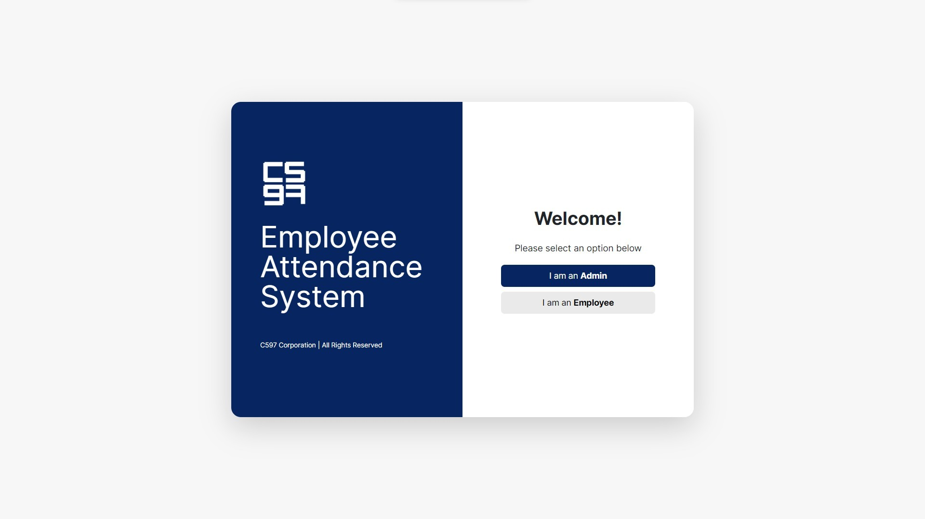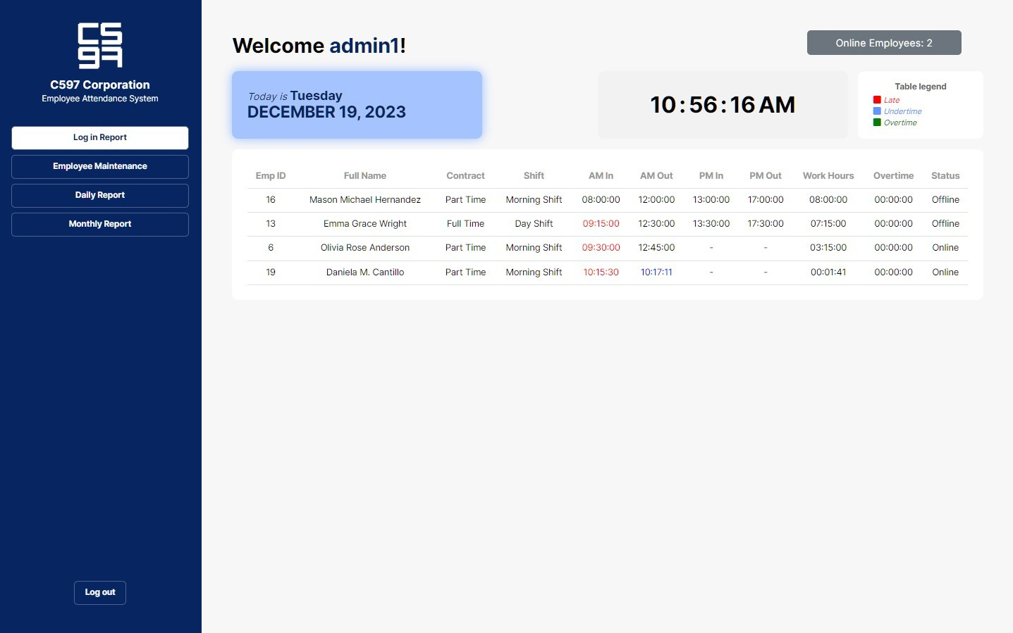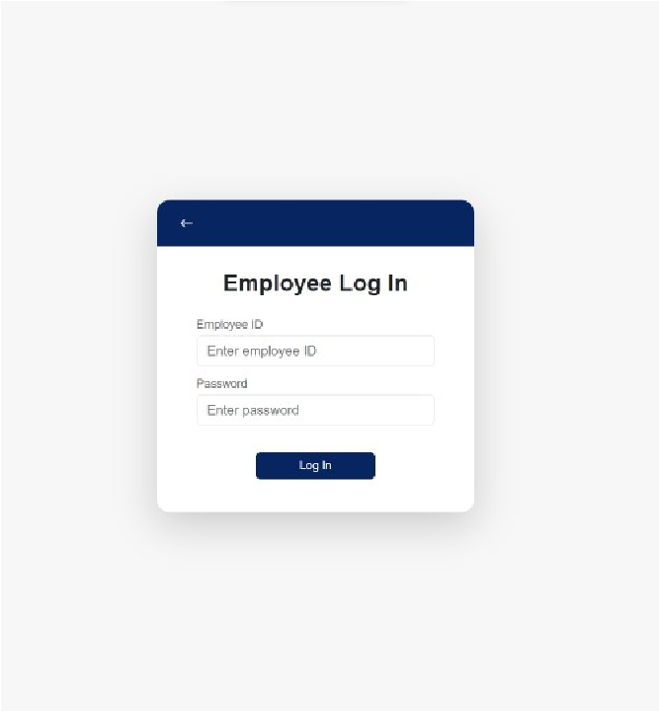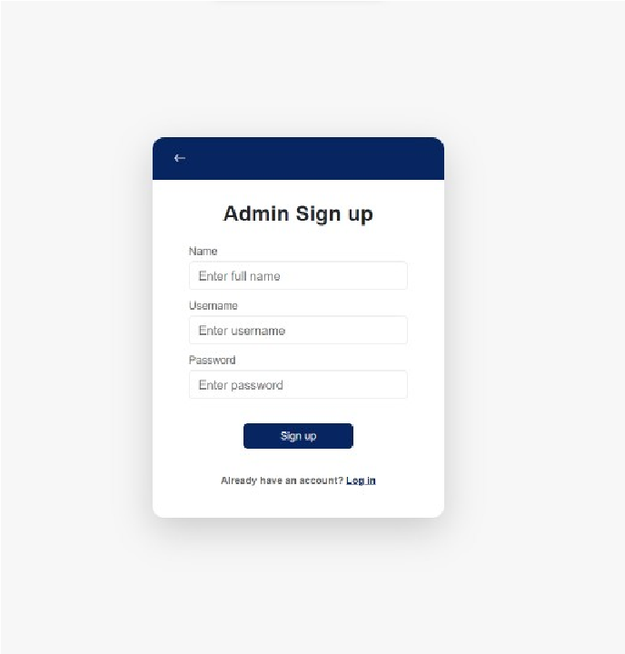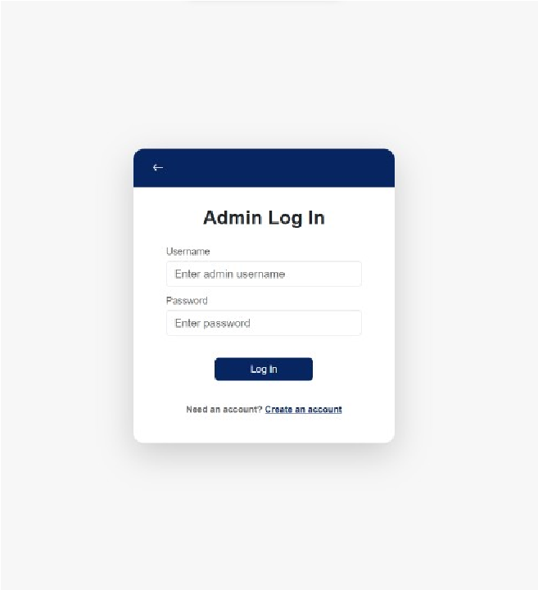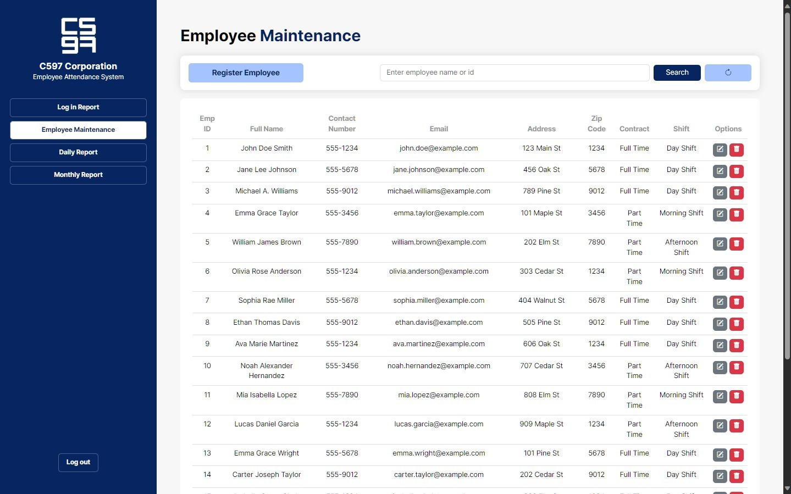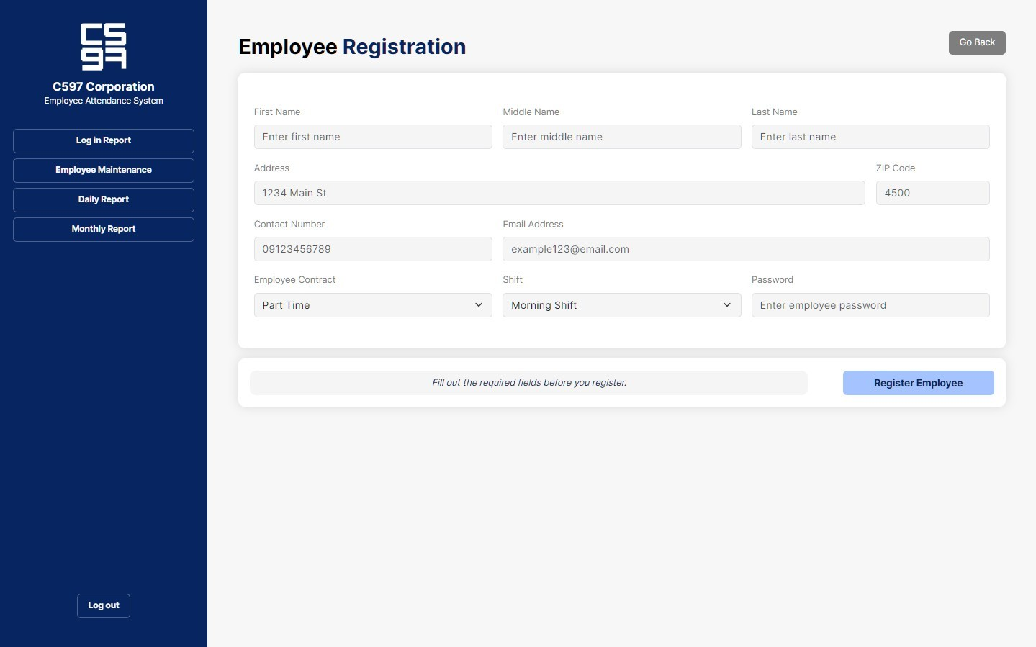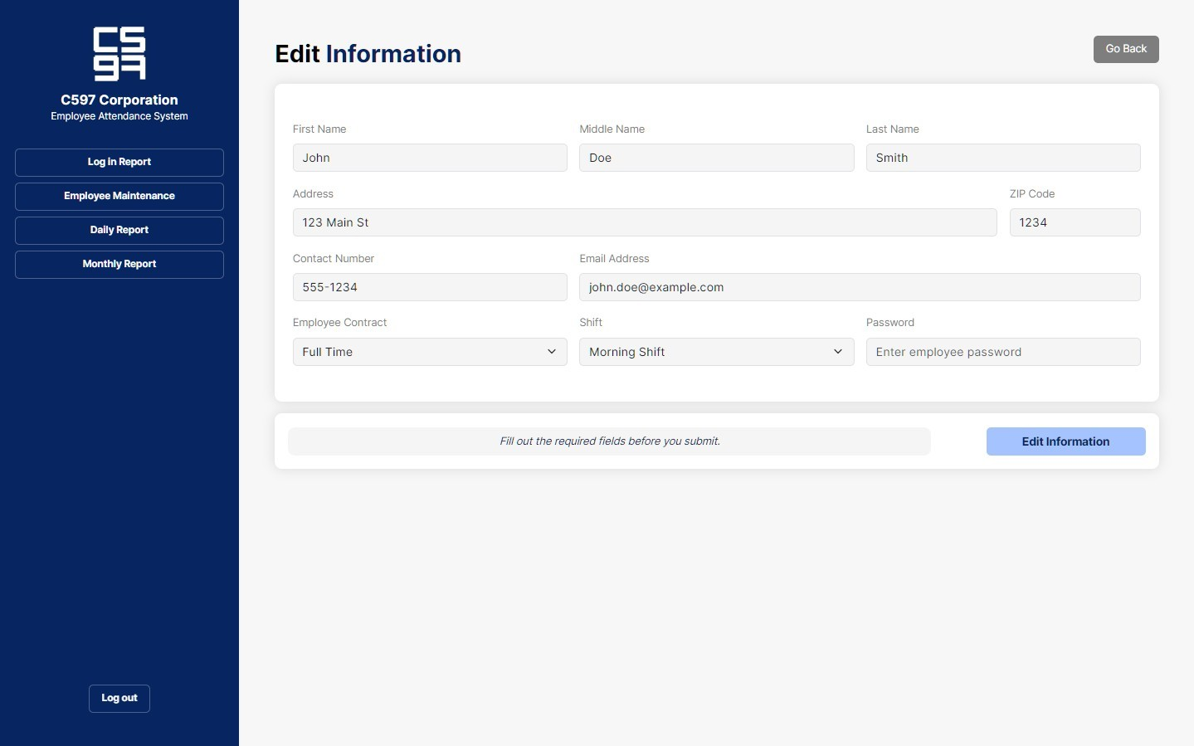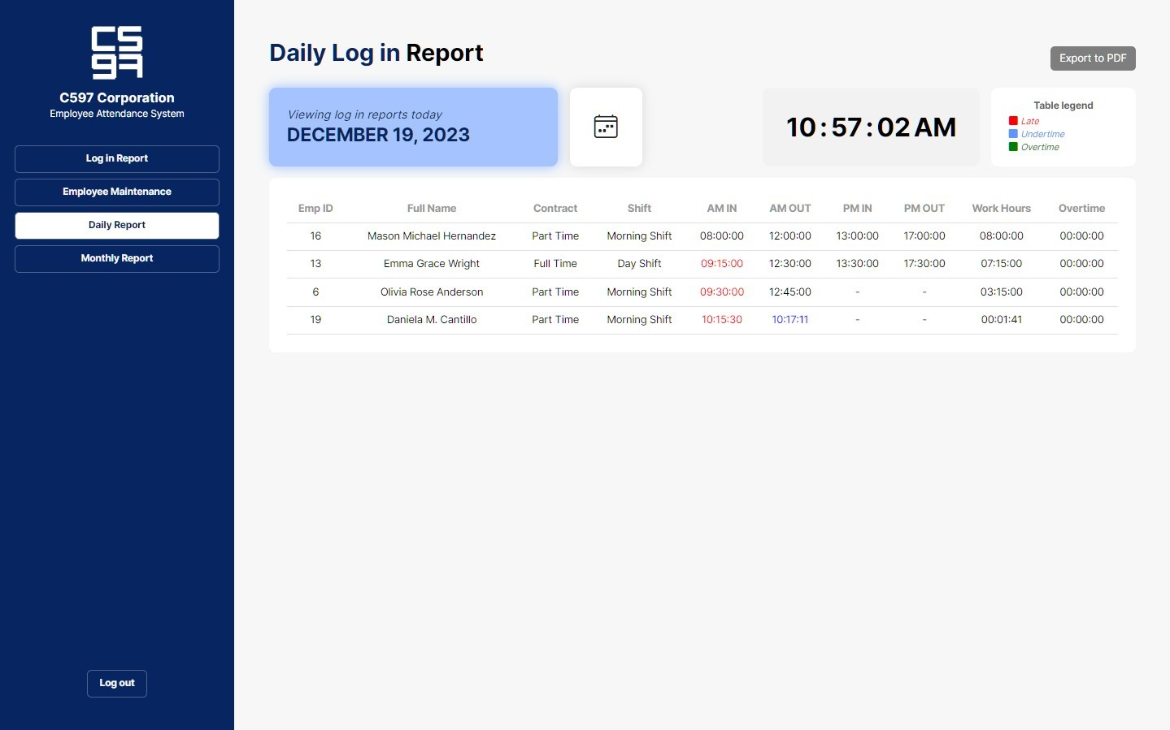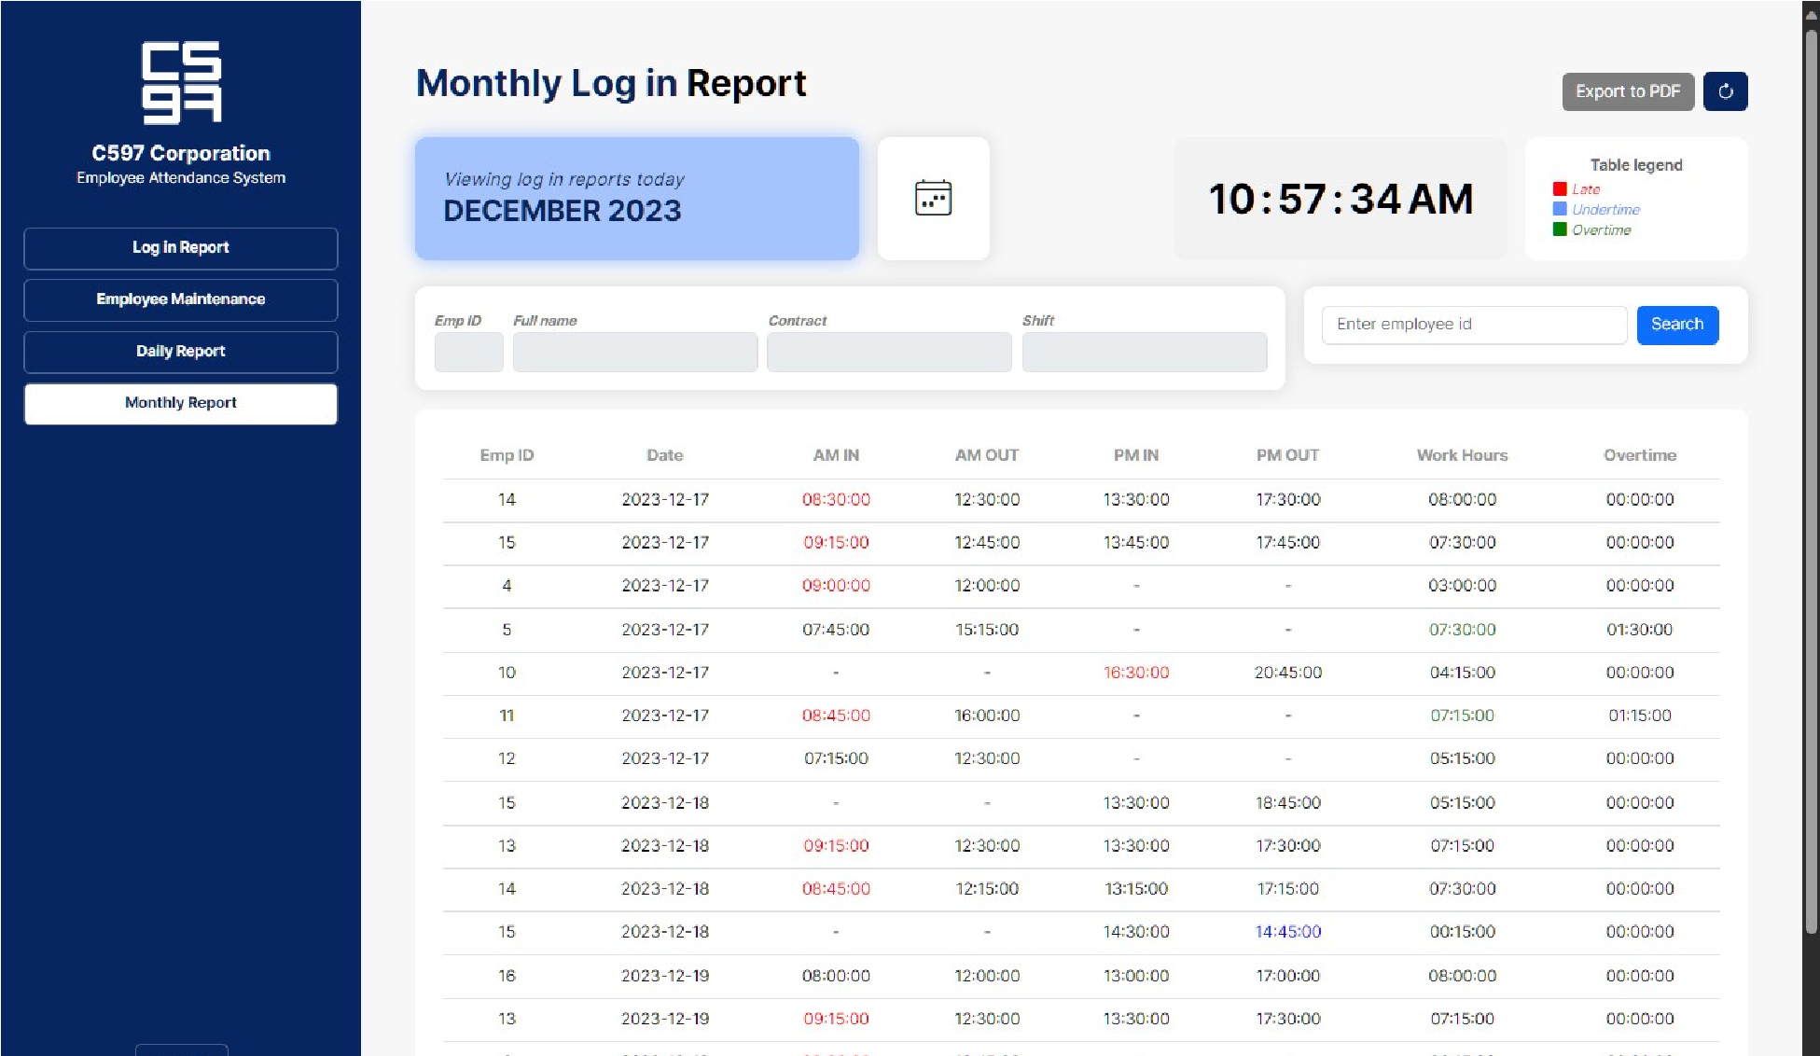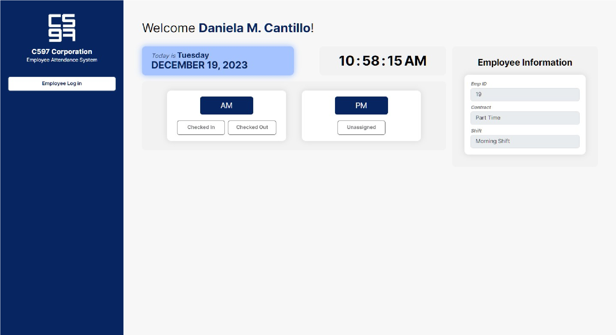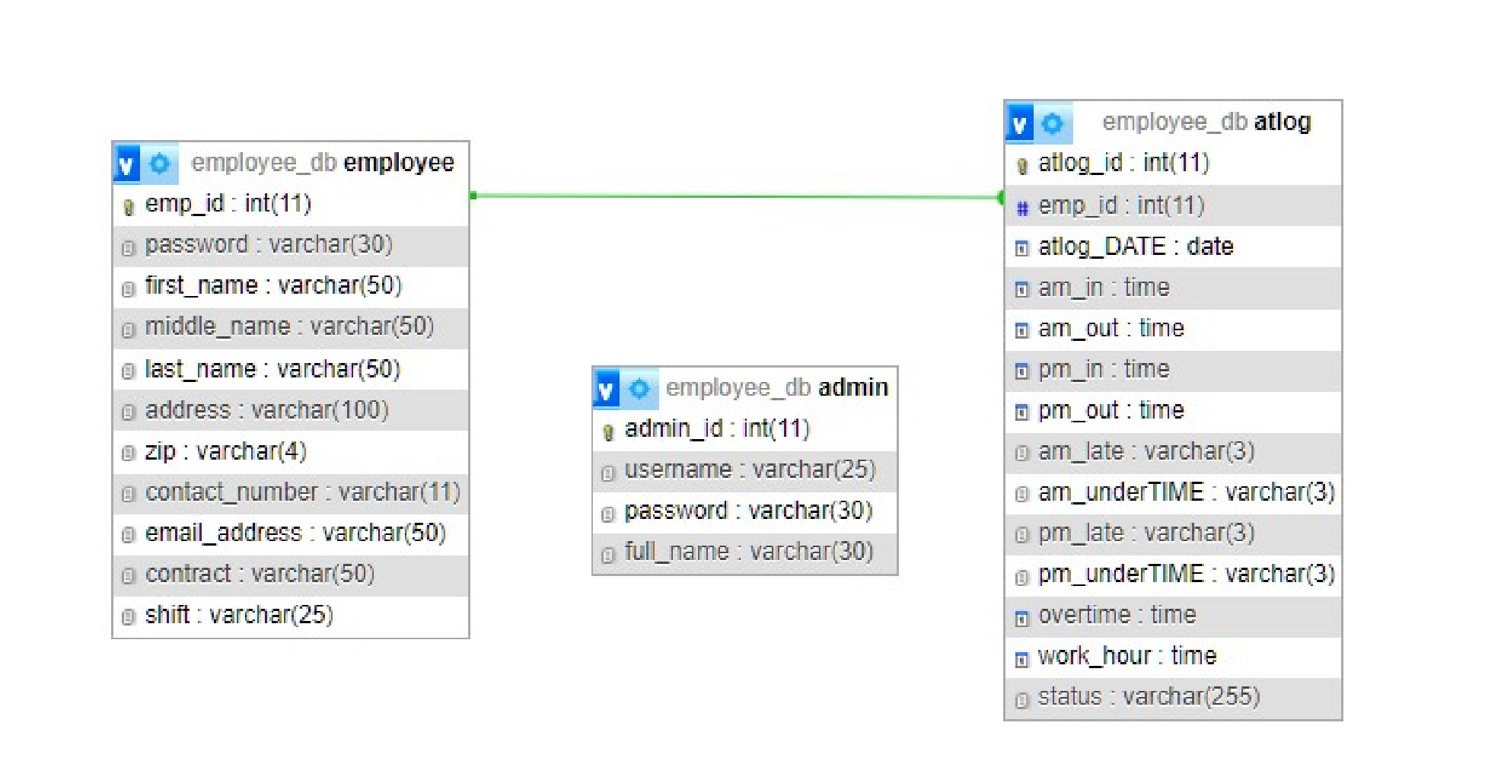

|  |  |
| --- | --- |
|  |  |
|  |  |
|  |  |
|  |  |

|  |  |
| --- | --- |
|  |  |

**CONCLUSION :**

TheEmployee Attendance Management System provides a reliable and efficient solution for maintaining employee attendance records in an organized manner. This system reduces manual work, minimizes errors, and improves overall accuracy in tracking daily attendance. By using digital attendance management, organizations can easily monitor employee presence, leaves, working hours, and generate detailed reports whenever required.

The system ensures better transparency between employees and management, supports quick decision-making, and enhances productivity. It also simplifies administrative tasks by automating the attendance process and securely storing all records in a database. Overall, this project demonstrates how technology can replace traditional manual methods and provide a more effective and user-friendly attendance management solution.